THE UNIVERSITY COOPERATIVE
Learning to manage academic resources as common property

14 May 2019, Belle van Zuylenzaal, Academiegebouw, Utrecht
Speakers
- Tine de Moor, Department of Social and Economic History, Utrecht University
- Bianca Kramer and Jeroen Bosman, FORCE11 Scholarly Commons Working Group and Utrecht University Library
- Lars Tummers, School of Governance, Utrecht University

Moderator
- Socrates Schouten, Waag

Nearly thirty years ago, Elinor Ostrom published her groundbreaking book Governing the Commons, in which she showed that users of natural and agricultural resources can and do govern such resources themselves. By making the rules together and complying, 'commoners' can manage their own resources. They don't have to rely on government regulation or corporate policy. They can face challenges and make decisions collectively. Ostrom also extended her work on commons governance to knowledge commons.
Sharing resources, such as data, methods, publications, and curriculum, is one of the foundations of university education and development. But today many academic resources such as subscriptions and the syllabi are managed in rigid, bureaucratic ways. Users often find it difficult to create and share new, openly licensed work in this controlled academic market.
This workshop will introduce you to issues, concepts, and successful examples of academic and nonacademic communities governing common resources. You will be involved in applying the concept of commons to concrete cases relevant to academia and knowledge creation, not just by listening, but by doing, together.

Questions: If we want to become decision makers of our shared resources, what do we need to learn? Which tools do we need? What rights are we missing?
Take away: We develop a clearer understanding of how to increase resource control among the academic community. We understand better how that has been done by others. We know where we should start and what steps to follow.
Effort: To learn together how the lessons from the commons can help academics in their work. To share and discuss what we and others can do right now. To sketch a roadmap that show us the way forward.

Registration: https://www.formdesk.com/universiteitutrecht/commons

This workshop is a joint effort by the Utrecht Young Academy, Open Science Community Utrecht, and Waag.

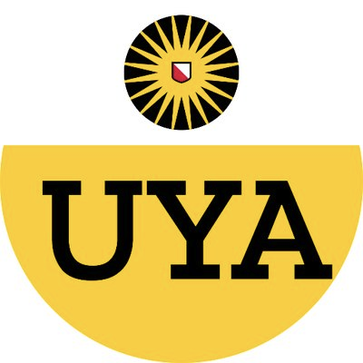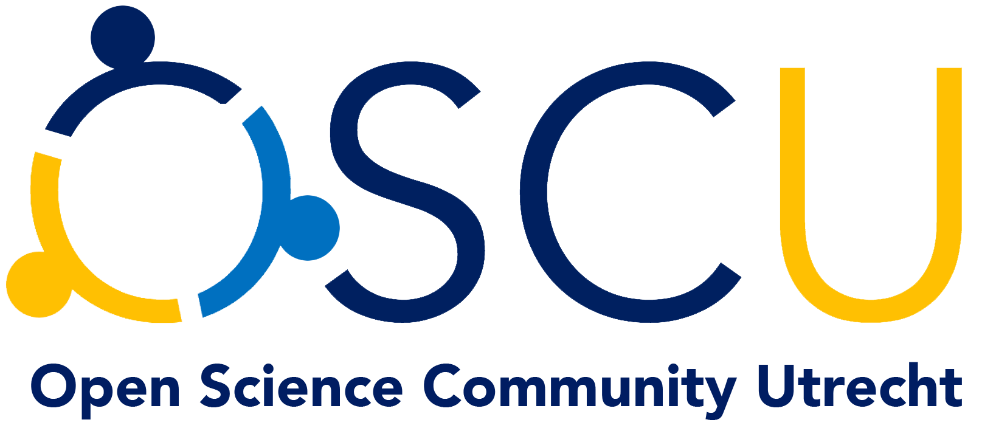

THE UNIVERSITY COOPERATIVE
Learning to manage academic resources as common property

14 May 2019, Belle van Zuylenzaal, Academiegebouw, Utrecht

10 - 10:15: Opening and introduction
- Format and aim of the workshop, Organizers

10:20 - 11:30: Theory
- The fundamentals of commons applied to academia, Tine de Moor
- Scholarly commons, Bianca Kramer and Jeroen Bosman

11:50 - 12:30: Solution space
- Towards accepted behavior change (ABC) in academia, Lars Tummers
- Managing collectives, (tba)

12:30 - 13:30: Lunch and group activity

13:30 - 16:00: workshop and discussion
Moderator: Socrates Schouten (Waag)
How can we design resource pools used by academics to be managed collectively? What decision making solutions would enable a larger group of academics to control these resources? What values are at stake and what community of peers would best cater to these?
- Introduction of cases
  - Allocating the library budget of a department
  - The tragedy of publish and perish
- Discussion round 1, problem formulation and identifying the limits
- Break out sessions for designing solutions
- Discussion round 2, critical view on the practicality of solutions
In the afternoon workshop, we will combine the morning’s theory with our own knowledge and experiences on resource-oriented processes in academia. We will focus on two main cases (mentioned above) and work in groups to start carving out new commons. We will work on the basis of design tools prepared by Waag.

16:00, rounding up

This workshop is a joint effort by the Utrecht Young Academy, Open Science Community Utrecht, and Waag.

